Total page number should be max six (6) pages (Times New Roman 14-Bold)
Name SURNAME^{1,}∗ , Name SURNAME² , Name SURNAME³ (Times New Roman 11-Bold-Italic-The name of the person making the oral/online presentation should be underlined.)
¹ Institute, Faculty, Department, University, City, Country (Times New Roman 9-Italic)
²Institute, Faculty, Department, University, City, Country (Times New Roman 9-Italic)
²Institute, Faculty, Department, University, City, Country (Times New Roman 9-Italic)

Abstract (Times New Roman 12-Bold)
In this study, the relationship between transport performance of Cr(VI) through PVDF-co-HFP based ionic polymer inclusion membranes (IPIM), alkyl chain length of symmetric imidazolium bromide based room temperature ionic liquids (RTILs), and morphological changes of these IPIMs has been comprehensively described. Butyl, hexyl, octyl, and decyl substituted RTILs containing IPIMs were prepared in different compositions and their effectiveness on Cr(VI) transport was experimentally optimized. In optimum conditions, the initial mass transfer coefficient (J_{o}) value of Cr(VI) was found as 5.0·10⁻⁶ mol·s⁻¹·m⁻², and also, we found that the optimized process is significantly selective for chromium in existence the other heavy metal ions. Morphological and structural characterizations of IPIMs have been performed before and after Cr(VI) transport to illuminate the morphological and structural changes. Also, the additional plasticizing effect of RTILs as an unusual morphological phenomenon has come forward. In today’s industrialised world, the demand for environmentally friendly processes for removal or recycle of toxic substances by simpler and cheaper ways have been increasing day by day. As a result, our developed and optimised membrane-based process seems to be overcome some Cr(VI) dependent environmental and industrial difficulties. (Times New Roman 10) (75-300 words)
Keywords: Keyword1, Keyword2, Keyword3, Keyword4, Keyword5(max.5) (Times New Roman 10-Italic)

- Introduction (Times New Roman 12-Bold)
In the world, each pollution types, existing in different environmental sources, affects a significant amount of the organisms who live in there [1-3]. The discharge limits of heavy metals at the end of the industrial activities should be held in the acceptable concentration limits according to the boundaries of World Health Organization (WHO) and EPA [4, 5]. (References should be given in order) The high-level intake or exposure to the chromium can create bad results on survival conditions of humans, animals and plants depending on the chromium species [6, 7]. Cr(III) in lower concentrations has less toxic than Cr(VI) on natural life. Cr(III) especially shows its toxic effects on the viscera of mammal organisms like liver and kidney [8-10]. (Times New Roman 11)
$E=m∙c^{2}$ (Times New Roman 11-Italic or Cambria Math 11) (1)
In the present study, we aimed to illuminate Cr(VI) transport through PVDF-co-HFP based IPIMs by using RTILs involving different lengths of alkyl chains. For this purpose, butyl, hexyl, octyl, and decyl substituted RTILs were synthesised and characterised using spectral and physicochemical characterization techniques like NMR, viscosity measurement, electrical conductivity, density, refractometry, etc.

- Materials and Methods (Times New Roman 12-Bold)
The reagents, 1H-imidazole, 1-bromo propane, 1-bromo hexane, 1-bromo octane and 1-bromo decane, employed in the synthesis of RTILs and were purchased from VWR (Seelze, Germany) and used directly in the RTIL synthesis without further purification. Dichloromethane, toluene, diethyl ether, hexane, N,N-dimethyl formamide, NH₄OH, Na₂CO₃, KOH, HCl, HNO₃, NaOH, and H₂SO₄ were purchased from Sigma-Aldrich (Sleaze, Germany) and used directly without any purification. Dichloromethane, toluene, diethyl ether, hexane, N,N-dimethyl formamide, NH₄OH, Na₂CO₃, KOH, HCl, HNO₃, NaOH, and H₂SO₄ were purchased from Sigma-Aldrich (Sleaze, Germany) and used directly without any purification. Dichloromethane, toluene, diethyl ether, hexane, N,N-dimethyl formamide, NH₄OH, Na₂CO₃, KOH, HCl, HNO₃, NaOH, and H₂SO₄ were purchased from Sigma-Aldrich (Sleaze, Germany) and used directly without any purification. Dichloromethane, toluene, diethyl ether, hexane, N,N-dimethyl formamide, NH₄OH, Na₂CO₃, KOH, HCl, HNO₃, NaOH, and H₂SO₄ were purchased from Sigma-Aldrich (Sleaze, Germany) and used directly without any purification. The suggested of method approach is shown in Figure 1.

Figure 1. The framework of the suggested method. (Times New Roman 10)

- Results and Discussion (Times New Roman 12-Bold)
  - Selection of working wavelength (Times New Roman 11-Bold)
We have illuminated the usage of imidazolium-based RTILs having different lengths of alkyl chains in symmetric positions as carrier in PVDF-co-HFP based PIMs as a carrier in Figure 2.
Figure 2. Absorbance spectra obtained in selected chemical conditions. (Times New Roman 10)

  - Effect of pH (Times New Roman 11-Bold)
Electrostatic interactions between chemical species vary depending on the pH of the aqueous solution. In the extraction experiments, the interaction between the analyte and the selected chemical medium should be high (Figure 3).

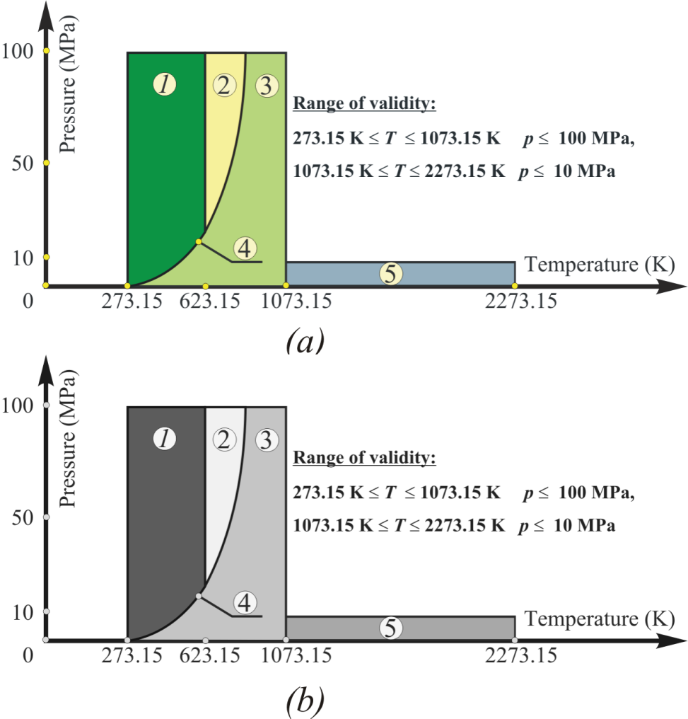

Figure 3. Use of appropriately contrasting colours for black and white printing: a) colour figure, b) greyscale figure. (Times New Roman 10)

Electrostatic interactions between chemical species vary depending on the pH of the aqueous solution. In the extraction experiments, the interaction between the analyte and the selected chemical medium should be high (Table 1).

Table 1. Table format in IKSTC: Template for tables. (Times New Roman 10)
Interfering species | Tolerance limits | Recovery (%) | RSD (%)
Sn²⁺ | 1000 | 94.7 | 2.1
Cd²⁺ | 1000 | 96.4 | 2.4
K⁺ | 1000 | 98.1 | 2.2
Co²⁺ | 1000 | 95.3 | 2.1
Mg²⁺ | 1000 | 96.2 | 2.0
Ca²⁺ | 750 | 96.8 | 2.8
Tartaric acid | 750 | 97.5 | 2.5
P4R** | 750 | 96.5 | 2.6
Fe³⁺ | 750 | 98.2 | 1.8
SO₄²⁻ | 500 | 94.4 | 2.7
Allura red AC | 500 | 95.9 | 2.5
Ascorbic acid | 500 | 97.1 | 2.6
Al³⁺ | 500 | 96.3 | 2.9
Brilliant Blue | 250 | 96.5 | 2.5
Sunset yellow | 250 | 93.4 | 2.4
Erythrosine | 250 | 93.1 | 2.1
Carmoisine | 100 | 92.4 | 2.8
Amaranth | 100 | 92.5 | 2.5
** Ponceau 4R (Times New Roman 9)

- Conclusion (Times New Roman 12-Bold)

We have illuminated the usage of imidazolium-based RTILs having different lengths of alkyl chains in symmetric positions as carrier in PVDF-co-HFP based PIMs as a carrier. Our proposed method yields similar results when compared with similar recent studies, as shown in Table 2 and Figure 4. As a result, we believe that the suggested method shows a good result in the diagnosis of breast cancer. n the future, other feature selection methods and classification methods can be considered as potential alternatives to the proposed scheme.

Figure 4. Use of appropriately contrasting colours for black and white printing: a) colour figure, b) greyscale figure. (Times New Roman 10)

Table 2. Comparison of suggested with some recent similar studies (Times New Roman 10)
References | Method | Dataset | ACC
[5] | SGLCM+GSOE+SVN | MITAS | 0.940
[6] | GHLRM+SVN | MITAS | 0.939
[7] | PSEO-FEFNN | MITAS | 0.913
This study | GHLRM+MBT+SVN | Private Dataset | 0.944

Acknowledgement

In this study, the financial support was provided by The Scientific and Technological Research Council of Turkey (TUBITAK), Project No. 112X8YY. All experimental works were conducted in Çankırı Karatekin University Research Laboratory. The author would like to thanks to all supporters due to their precious contributions.

References (Times New Roman 12-Bold)

- Surname, N., Surname, N., Surname, N., & Surname, N. (All names should be written) (Year). Title of the article. Title of the Journal, Volume(issues if used), pages. (Journal-Title of the Journal should be written in italics-Times New Roman 11)
- Surname, N., Surname, N., Surname, N., & Surname, N. (Year). Book Title(edition if used). City of publication, Country/State: Publisher. (Book-Book Title should be written in italics)
- Surname, N., Surname, N., & Surname, N. (Year). Title of the book chapter. In N. Surname & N. Surname (Eds), Book Title (Pages). City of publication, Country/State: Publisher. (Book chapter-Book Title should be written in italics)
- Surname N., (Date), Title of Document [Format description] (ppt, doc, pdf, etc.), Retrieved date (Month Day, Year) from website link. (Website- If there is no date “n.d” should be written and Title of document should be written in italics)
- Surname N., Title of thesis/dissertation, PhD or MSc Thesis, Title of University, Title of Institue, Year, Total page number, City. (Thesis and dissertation- Title of Thesis/Dissertation should be written in italics)
- Surname N., Title of Full-text Conference Paper, Title of Conference, City, Country, Year, Page. (Conference-Abstratcs in conferences are not accepted as a valid reference except full text)
- Surname N., Surname N., Surname N., Surname N. & Surname N. (2008). Title of Full-text Conference Paper, Title of Conference, Location, Volume, Page. (Online Conference-Abstratcs in conferences are not accepted as a valid reference except full text)

The committee recommended that authors follow APA 6 writing guidelines if the above reference examples are inadequate.

* Corresponding author. e-mail address: .........@.....

